**ASSIGNMENT 15.1**

PROBLEM STATEMENT

(i) **Write a simple program to show inheritance using scala.**

Solution:

Inheritance: Extending a class and inheriting all the features of a parent class is called inheritance but Scala allows the inheritance from just one class only.

Source code:

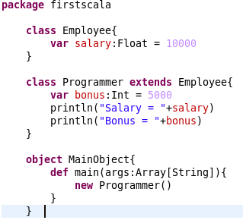

Output:



(ii) **Write a simple program to show multiple inheritance in scala.**

Solution:

Since ‘java’ does not support multiple inheritance but ‘Scala’ is different as it uses ‘traits’ concept to implement multiple inheritance.

Traits: A trait encapsulates method and field definitions, which can then be reused by mixing them into classes. Unlike class inheritance, in which each class must inherit from just one superclass, a class can mix in any number of traits. Scala also allows traits to be partially implemented but traits may not have constructor parameters.

Source Code:

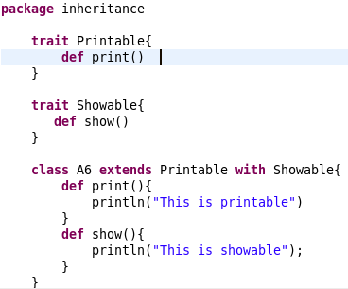

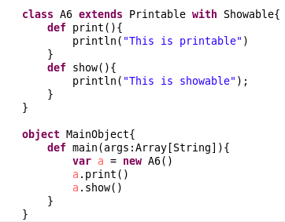

Output:

